- Overview
- This document defines the required adaptations of the Signal Tower to the Objet1000.
- Objectives
  - Define color setup for the signal tower for the XL machine throughout its operating states & conditions.

- Current implementation problem
  - Not applicable

- Detailed solution description
  - Green light will indicate normal condition. In the XL machine this means printing (From host PC and local print job). Green light shall be ON during Per-Print and Printing states.
  - Green light will also be lit during printing period of any wizard.
  - Green light will be flashing (50% duty cycle: 1 second ON and 1 second Off), after printing was complete successfully and the doors were not opened yet. Flashing shall start in Stopping state until door was opened (interlock signal).
End of stopping sequence shall flash the Green.
Upon opening the door/interlock signal opened, the Green light shall be switched off.

  - Flashing Yellow light will indicate that a user intervention is required:
      - Model/Support/Waste cartridge replacement is needed:
        - When model or support cartridges total weight of allowed cartridges is empty during printing/pre-printing phases.
A message is posted to the user.


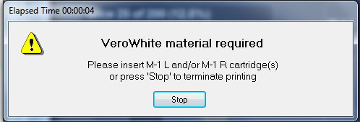
Yellow flashing shall stop, when this message disappears.
        - Same mechanism shall apply for waste cartridges as well. When present cartridges are full, when a warning is posted the Yellow light shall flash.
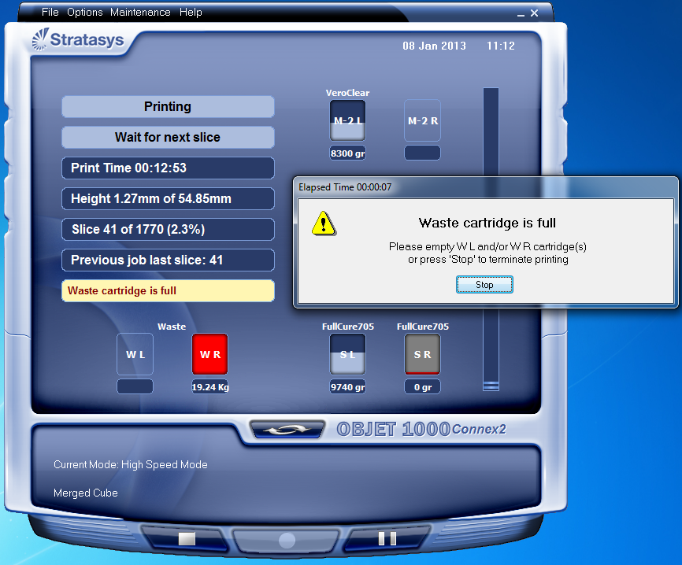
Yellow flashing shall stop when the message in the main GUI disappears.
      - This mechanism shall apply for removed cartridges as well:
        - When there is not even one allowed resin cartridge present for either model or support.
      - The flashing shall start when a message is posted to the user (same message as above).

Yellow flashing shall stop when the message in the main GUI disappears.
        - When there is not even one waste cartridge present.
The flashing shall start when a message is posted to the user.
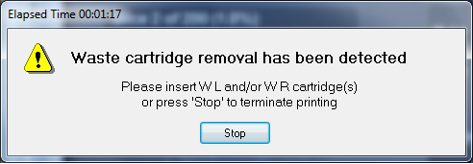
Yellow flashing shall stop when the message in the main GUI disappears.
  - Red light shall be ON to indicate that a stop-printing-fault has occurred during Pre-Print and Printing states.

  - Turning Off the Red light shall be done in two methods:

      - Pre-print state shall reset Red light status (if problem persists, Red light shall be turned On again upon the new occurrence of the error).
      - Restarting the EM application shall also reset all light statuses.

      - Bypass – The traffic light action can be activated or bypassed according to a parameter in the parameter manager under system. Default bypass value shall be Off (Signal tower not bypassed).

- Next Phase
  - EM-OCB communication error
      - In case of lost communication during user-activated EM application shutdown, the signal tower shall be switched Off (in OCB FW).
      - In case of lost communication during without EM application user-activated shutdown, the signal tower shall turn On is Red light.
  - The Red light shall be flashing due to interlock open. When interlock is closed again, the Red light shall switch back to its previous state (Off or On).

- Reference
  - Standard provided by Ra’anan – regulatory consultant.
